Intellaturbine
Dwayne Smith, Joaquim Thompson, Timothy Knob, Jose Dominguez

School of Electrical Engineering and Computer Science, University of Central Florida, Orlando, Florida, 32816-2450

Abstract — This paper presents the design solution used to create an alternative energy system utilizing a wind turbine and battery bank. With the ever increasing cost to produce energy, research for alternative energy sources is on the upward trend. The system presented in this paper will be capable of sustaining the average household allowing to be removed from the power grid. The system will employ maximum power point tracking in order to maximize the energy generated by the wind turbine. In addition to this, the system will also monitor the current and voltage of both the wind turbine and the battery bank. This data will then be displayed and stored, where after it can be exported and analyzed by the appropriate analytic tool.

Index Terms — Batteries, DC-DC power converter, microcontroller, power MOSFET, rectifiers, wind power generation.

I. Introduction
It is the intent of this senior design team, Intellaturbine to design and construct a power generation system. This system will utilize a wind turbine to generate power and a battery bank to store said power. The main purpose of the system is to use renewable energy (wind) to power the average household getting it off the power grid. The system will be a smart design utilizing maximum power point tracking (MPPT), having user adjustable parameters, data logging capabilities and real time output display.
This document will outline all the requirements and goals for this project. The team will take a systematic approach in designing this project. Firstly, a great deal of research will be done so that the team will have an extensive understanding of wind turbine design and implementation. Next, the design phase will begin; here the project will be broken into different segments, with each team member being assigned multiple segments. The team will start to build and simulate circuits separately before recombining. A plethora of test scenarios and documentation will then be developed covering both real world and ideal situations.
It is the intent that the goals listed in this document be completed over two academic semesters. In the first, research, design and some hardware acquisition will be completed. In the second semester a prototype will be built, tested and documented illustrating all the design requirements lists in this document. All major components in this project will be sponsored by Shaun Dunbar who will retain ownership of these components. Mr. Dunbar will also serve as a mentor and upon completion a working prototype will be presented to him.

II. System Overview
The objective of this project is to design a wind turbine system for individual home use. The intent is to design and implement an intelligent wind turbine system at a cost where it would be feasible for homeowners. The system once operational should require little to no interaction from the end user. Maximum power point tracking will be applied to get the maximum possible power to the system.
Below is an overview of Intellaturbine. The wind turbine will produce and AC output that will be fully rectified. A charge controller will manage the current from the rectified input. Data logging from voltage, current and wind sensors are available for transfer to an SD card for user analysis. Output voltage will be controlled through a DC-DC converter which is in turn controlled by the MPPT.

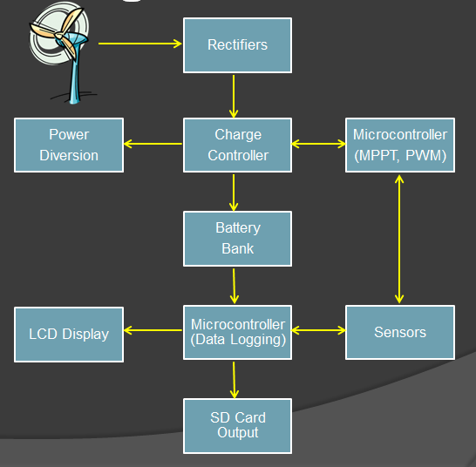
Fig. 1. Block Diagram.

III. Power Components

This design required two major components in order to generate and store power; a wind turbine and a battery bank. These two components were not designed by the team but rather researched and acquired as a part of the overall system. A charge controller with a DC-DC converter utilizing a MPPT algorithm was then used to regulate the power being supplied to the battery bank by the wind turbine.

A. Wind Turbine

This design requires a wind turbine capable of generating 500 watts at 24VDC. As this project is sponsored the choices of turbines were limited to our sponsor’s request. The team was however, allowed some flexibility to research for a better more capable option. After extensive research it was agreed that our sponsor had made a good choice. The TLG-500 series of wind turbine capable of producing 500 watts at 24 VDC was our turbine of choice.

At first glance the TLG-500 seems to be expensive when compared to other 500 watts rated turbines. However, the difference here is that the TLG-500 output is rated in real world and not instantaneous output. Another plus is that the TLG-500 comes under rated from its manufacturer; this is good news for the team because it means all our power requirements will be met. The following table illustrates the approximated watts and voltage produced by the turbine at different RPM’s. The figures were generated from the manufacturer’s website.

Table I
RPM vs. Watts and Voltage Produced by TLG-500
TLG-500 Turbine
Rotation Speed | Approximated Watts | Approximated Volts
(RPM): | Produced: | Produced:
100 | 40 | 10
200 | 100 | 17
300 | 300 | 25
400 | 500 | 34
500 | 650 | 42
600 | 700 | 50

B. Battery Bank

There are many different types of rechargeable batteries which are classified based on the chemical reaction they use such as sealed lead acid, lithium ion, nickel metal hydride. Considerations for the type of battery are maintenance cost and battery life. One of the oldest rechargeable battery systems is the lead acid system. It is durable and has a low specific energy. Its major advantage is that it is really simple to determine the state of charge by measuring the specific gravity of the electrolyte. The nickel-cadmium batteries characteristics are that it has a long service life and high discharge current. Due to environmental concerns the nickel-cadmium is being replaced with other chemistries. The nickel-metal hydride has a higher specific energy with fewer toxic metals. It is used for medical instruments and hybrid cars. One of the most promising battery systems is the lithium-ion.

Lead acid flooded batteries were chosen to be implemented as the battery bank. They were chosen because of their low maintenance cost and discharge rate among other characteristics. In this system there will be four 6V lead acid flooded batteries that will combine in series for a 24V battery bank. Each batter is rated at 520Ah at the 20Hr rate.

Rechargeable batteries are charged in three stages to preserve battery life. The first stage is the bulk charge which applies to the bulk of the charge and takes up about half of the required charge time. The maximum safe current is used to charge the battery until it reaches 80-90% charge. Maximum current is limited by the amp-hour of the battery. Second is the absorption charge which continues charging at a lower current and provides saturation. The absorption stage charge time is determined by the equation
$t=0.42\frac{C}{I}$, (1)

where C is the capacity of the battery and I is the current. The last stage is the float stage. During this stage the battery is charged at a current less than 1% of the battery capacity to counteract the self-discharge rate of the battery.

IV. Charge Controller

The charge controller design uses a DC-DC asynchronous buck converter to charge the battery system. A pulse-width modulated signal will determine the output of the converter through a microcontroller. The maximum power point tracking algorithm will determine the charge stage of the system. The algorithm will also control the activation of the dummy load to protect the system from being destroyed.

Intellaturbine will be using DC batteries to store and distribute the output from the TLG-500 wind turbine. The output from the turbine is AC but in order to charge the batteries DC power will be required. Hence the AC output will have to be rectified to produce a DC output. Rectification is a process of converting an alternating voltage (AC) into one that is limited to one polarity (DC). A full-wave rectifier converts both halves of the input signal to one constant polarity at its output. For this design, the circuit designer can also choose which polarity passes by the diode’s orientation. The circuit design and construction is more complex than that of the half-wave rectifier as the full-wave rectifier uses more diodes. There are different designs of full-wave rectifiers, the bridge rectifier design will be used for this project. The bridge rectifier uses four diodes and provides good isolation between the AC input and rectifier output. The DC voltage of an idea full-wave rectifier can be calculated by the following equation:

$V_{DC}=2\frac{V_{PEAK}}{π}$ (3)

where,
$V_{PEAK}=\frac{V_{RMS}}{(1-\frac{1}{е})}$ (4)

For three-phase AC which is the output of the TLG-500 six diodes (three pairs) are used. Each pair of diodes is connected in series, anode to cathode. Commercially available diodes typically have four terminals so they can be configured for single-phase split supply, half bridge or three-phase use.

For an efficient transfer of power an asynchronous buck converter was used as the primary DC-DC converter. The converter consists of an output capacitor, an inductor, and a diode. It also uses four high current paralleled N-channel power MOSFETs. The MOSFETs are activated by a PWM input at a frequency of 62.5 kHz. The ATmega328 creates PWM wave as the MPPT algorithm calculates the required duty cycle. The buck converter’s power MOSFETs were driven by the IR2104. This high side driver was chosen because of the wide supply voltage range and very short turn on/off time. The dummy load for the charge controller is activated using the MIC5011 high/low side driver. On/off time was not a factor in its selection of this driver but its ease of implementation made it and adequate choice. The dummy load runs through another set of paralleled power MOSFETS to handle the high current.

The inductor value was calculated with help from TI’s DC-DC converter module to be at least 45μH for this project. The inductance equation and output capacitor equations are as follows:

$D=\frac{V_{IN}}{V_{OUT}}$, (4)

$I_{R}=0.3I_{L}$, (5)

$L=\frac{(V_{IN}-V_{OUT})(\frac{D}{F_{SW}})}{I_{R}}$, (6)

$C=\frac{\left(ΔI*ΔT\right)}{(ΔV-\left(ΔI*ESR\right))}$ , (7)

where
$ΔT=\frac{D}{F_{SW}}$ (8)

and
$I_{D}=\left(1-D\right)*I_{L}$ (9)
D is the duty cycle used to control the output voltage of the buck converter. The initial value of the duty cycle is 0.95. Fig. 2 shows the setup of the buck converter along with the microcontroller that will control the duty cycle.

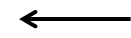
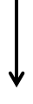
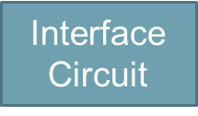


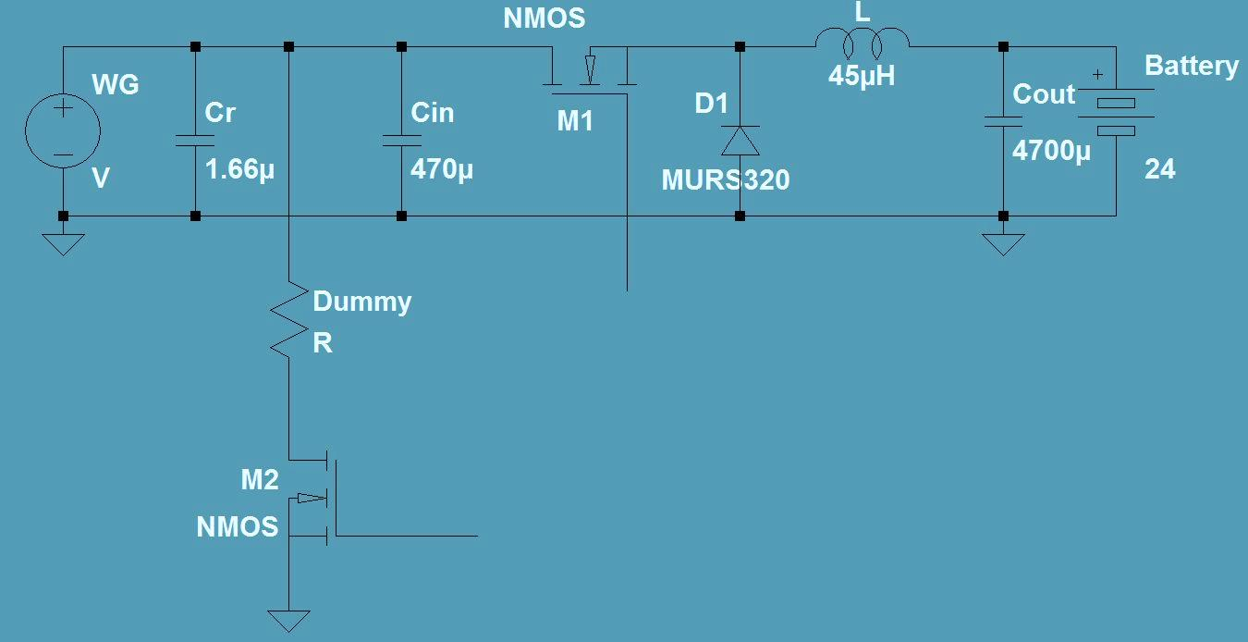
Fig. 2. Buck converter with sensing circuits and microcontroller interface.

High efficiency is desired when designing power systems. Therefore a decision was made to use maximum power point tracking to reduce energy transfer loss when converting from wind to electrical energy. There are many different types of maximum power point tracking methods that are available, mostly for solar energy. The different types ranged from very accurate and hard to implement to acceptably accurate and easy to implement. The MPPT algorithm used is the constant current method. During the main part of the charging stage the voltage will be held constant. This MPPT process is based on using measurements of wind generator output voltage and output current and adjusting the duty cycle of the DC/DC converter according to the comparison between successive generator power values. It will start with the bulk stage in which the output voltage needed to charge the battery will be determined by the equation
$V_{OUT}={CV}_{BATT}$. (10)
The constant C was determined by the maximum battery voltage and the voltage needed to charge a 2 volt cell battery during the bulk stage. This ensures the output voltage of the DC-DC converter is always higher than the battery voltage. As the battery voltage increases so will the output voltage. The MPPT algorithm will calculate the change needed and the microcontroller will augment the duty cycle of the square wave. The algorithm will also determine the voltage needed during the absorption stage using (1). In this stage the voltage is held constant as the current decreases. The float stage of the charge cycle is used to maintain the battery voltage. In this stage the duty cycle is set low to reduce the batteries self-discharge. The last task of the MPPT algorithm is to turn the dummy load on and off. Fig. 3 shows the flow chart for the MPPT algorithm.

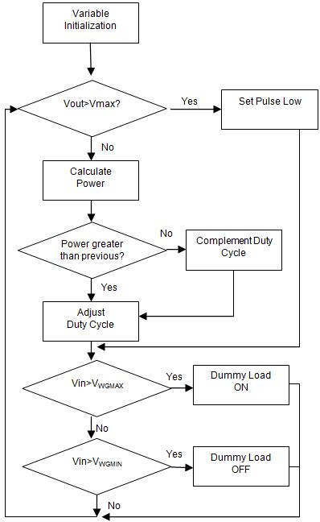

Fig. 3. MPPT Flowchart.

V. Software

The software segment of this design will be tasked with two major duties: the MPPT algorithm and the data display and logging requirements. The Atmel® line of chips seems to be the microcontroller of choice for most projects of this nature. The ATmegaXX8 series prove to possess the parameters well within our specifications, with the ATmega168 and ATmega328 being the MCUs of choice. By all accounts the 328 is identical to the 168, having an 8-bit AVR CPU, a max clock speed of 20 MHz, pin size of 32, 23 I/O pins, an 8-channel, 10-bit ADC, and an operating voltage of 1.8 to 5.5 V. However, Fig. 4 shows the ATmega328 which has a doubled memory size over the 168; with 32 kB of programmable flash memory over the 16 kB on the mega168, 2 kB of SRAM over the 168’s 1 kB, and 1 kB of EEPROM over the 168’s 0.5 kB. Atmel® supports its AVR-based chips with AVR Studio® 5, an IDE that allows the coding of assembler and C/C++ projects within any Windows platform. The inclusion of an integrated C Compiler is the major feature that allowed it to be used for the Intellaturbine project.

The ATmega328 chip is the central component in a microcontroller platform manufactured by a company named Arduino. The Arduino Duemilanove is a microcontroller development board that is fully supported by open source software and even hardware, in that the schematics for the boards are published freely under a Creative Commons license and are free to be modified by the user as he wishes. Arduino uses their own IDE and programming language for developing code on the board, which claims to be simple to learn and use – not to mention free. This IDE is the platform used for the development of the data logging routine. It has six pins dedicated to PWM of frequencies up to 62.5 kHz. The Atmega328 can also use bit-banging pulse width modulation, which is an essential component of the MPPT routine.

For data displaying purposes the Hitachi HD44780 LCD will be used. The ATmega328 will be able to interface with the LCD at up to 2 MHz and will write four bits of data at a time. It has four lines each capable of 20 characters.

An LT1934 switching regulator will be used to power the 5V ICs from the battery voltage and a LT1761ES5-3.3 linear voltage regulator along with a level shifter will be used to power the 3.3V components. These include sensitive components such as the SD memory card, which can safely handle up to around 3.3V without scrambling the data.

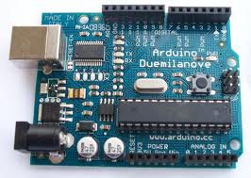
Fig. 4 ATmega328 with development board.

VI. Sensing Circuits

In order for Intellaturbine to monitor its own performance, current and voltage sensors must be incorporated in the design to measure these variables. These variables will be used in the MPPT algorithm for power calculations to ensure the design is reaching the maximum efficiency. The current and voltage outputs from the sensing circuits will also be used for data logging and display. While it may be easy to measure current and voltage with common Electrical Engineering equipment, the LCD display and data logging subsystems rely on a very specific voltage signal to prevent damage to the system with values that are beyond the device’s standard operating limits.

An analog voltage signal will not get far within a microcontroller without a built-in analog-to-digital converter; luckily all of the choices in MCU would accommodate this. The ADC will sample the incoming analog voltage signal at discrete time periods and voltage levels, often producing a histogram-like effect. Depending on the bit resolution and sampling rate of the ADC being employed in the design, there may be a more or less faithful digital reproduction of the original signal.

To measure the present battery voltage and relay this information into the processor, some simple procedures can be followed. To scale down the often very high voltage levels in the battery without affecting the integrity of the voltage signal – all the while being compatible with our chosen microcontroller – a voltage divider circuit is usually the best choice for reducing the incoming voltage signal and reaching safe input levels.

Measuring the current produced by the wind generator gives us the opposite issue; the proportional voltage signal that is often produced by the special low-Ohm shunt resistor is much too small for the microcontroller to understand or make sense of. Luckily various solutions are available in the realm of high-side current sensing. One may use a simple differential amplifier in tandem with several precision-configured resistors to produce the desired proportional output voltage from the shunt resistor, be it with traditional circuitry or discrete IC components.

The InSpeed Vortex, shown in Fig. 5, was used to measure wind speed for Intellaturbine. It consists of an anemometer, which is a 3-cup rotor mounted on a vertical shaft. As the anemometer rotates, it should have a reed switch and magnet system that closes the device contacts once per rotation to create a pulse. The frequency of these pulses is proportional to the actual wind speed, and this information will be wired to the output signal of the sensor. From there the actual wind speed can be converted and calculated by the microcontroller to display.

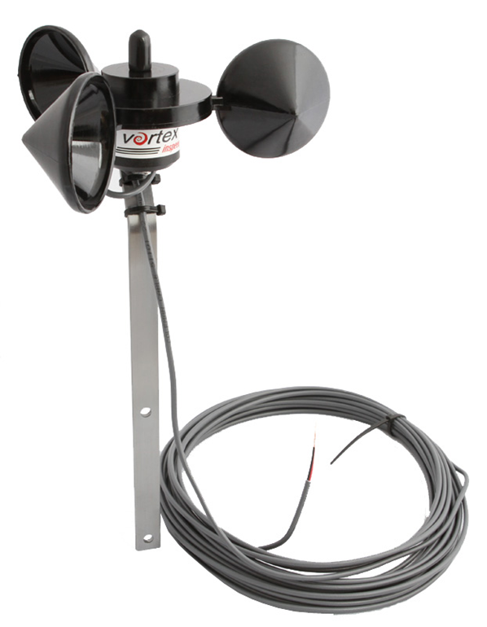
Fig. 5 InSpeed Vortex.

The method we used to interface the wind speed sensing system with the ATmega chip was to repeatedly poll the device using software and look for changes in state. The device we decided to use for this purpose is a generic JK flip flop IC with a reset capability. The flip flop is defaulted to a high output (i.e. J=1 and K=0) and the clock input of the device comes from the wind sensor proper. This connection is made with a de-bouncing circuit, including a pull-up resistor and a capacitor between the two leads. The output of the flip-flop will be sent to the Atmel, while the Atmel will clear the flip-flop via the reset pin to wait for the next pulse.

The sensors for current and voltage, as well as the systems that condition the signals to be compatible with the microcontroller will include an active low pass filter that removes all frequencies greater than one half the sampling rate to eliminate unnecessary aliasing on the analog signal before conversion, which in turn serves to smooth out the signal by allowing a low sampling frequency.

As the Arduino Duemilanove will have the ATmega328 processor installed, the memory and code space implications of accommodating the required libraries and interfacing with the FAT16/32 file system used on most SD cards are not as unattainable, so there is plenty of room to breathe as far as freedom of code space is concerned. The Adafruit Logging Shield can be used with the Arduino. The components introduced by the data logging shield will require 2 analog input pins for the real-time clock and 4 digital input pins for the SD card interface and power supply. On the Arduino, this leaves only 4 analog input pins (suitable for the 4 analog sensor signals we will be using) and 9 digital input pins. As the SD card will require a larger amount of power for its write operations than what the Arduino can provide, an additional power supply (rated 3.3V @ 250 mA) is included on the data logging shield that may provide the 5V V_{cc} to the SD & MMC reader as the device requires it. Finally, one red and one green LED are featured on the board to indicate when the SD device is being written to. Helpfully, the Eagle schematic for connecting these two components was provided for reference on the Adafruit Industries website and a rough sketch will follow in Fig. 6.

Fig. 6. Interface between Arduino and Data Logging Shield.
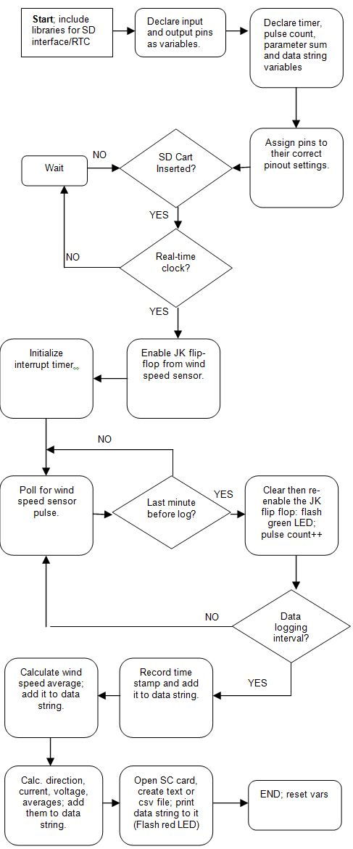

Fig. 7. Data logging routine for wind, current, voltage, and clock.

As the Intellaturbine includes very useful sensor a data logging system is implemented in the design is to provide a greater understanding by the end user as to where and how the Intellaturbine may be installed for max efficiency. If and SD card is detected data will be stored. The data, once taken from the device via a portable storage medium and put into formatted for FAT32 for the user, is an important step in analyzing the efficiency of the design, given factors such as battery voltage levels, wind speed and direction, and current in the design. By using and interpreting this data, the user may attempt on his own terms to negotiate a greater level of efficiency or determine whether his immediate area is feasible for wind generation. The data logging routine shown in Fig. 7 will display the data to be logged, delimited by commas, and is as follows:

MM/DD/YY
- HH/MM/SS
- Wind Speed (mph)
- Current (A)
- Battery Voltage (V)

The DS1307 real-time clock was used to keep time for the data logging system of Intellaturbine. This clock is able to keep time up to 2100, has a backup battery, 56k of non-volatile SRAM, and accounts for leap years.

VII. Printed Circuit Board Design

The PCB was designed using Altium Designer 10. Advanced Circuits produced the board which has three layers. The top layer of the PCB is the power layer and the bottom layer is for the sensing circuits. Advanced Circuits was chosen because of their fast quotes and on time shipping record. The dimensions of the PCB are 6” by 6” and because this is a high power application the PCB needed a much heavier copper. The board was designed to handle a 20°C temperature rise. Fig. 8 shows the top layer of the PCB that includes the high-power components.

VIII. Testing

Testing is an integral aspect of any design and implementation. Ensuring a project meets its design requirements is not only important to demonstrate that it works but also ensure safety requirements are adhered to. For testing, the project will be divided into several segments such as: wind turbine, charge controller, voltage regulators, bridge rectifier, data storage, data display and wind speed/tracking capabilities. During prototyping for each segment, all parts will be tested at the component level to ensure its correct operation before integration. After which each segment will be tested separately and then combined for an overall test in real world and simulated conditions.

During the test of the PWM wave form it was noticed that the big-bang mode was the only way to pulse width modulate the waveform at 40 kHz. Due to the non-continuous waveform the pulse could not be sustained and so the initial frequency of 40 kHz had to be changed to match one available through the ATmega. The maximum attainable frequency of the microcontroller is 125 kHz. From there the other sustainable frequencies are halved, 62.5, 31.2, 15.6 kHz, etc. After testing the several different frequencies 62.5 kHz was chosen and successfully implemented through these proceedings.

Due to the high current capabilities of this system a strict checklist will be developed and adhered to while testing the complete system. The list will verify that the wind turbine is producing power, the batteries are being charged/discharged, the data logging and display features are operational and all the voltage and current sensing circuits are operating to specification. This list will also be used to monitor the safety aspect of the project, not only to protect personnel from injury but also the equipment.

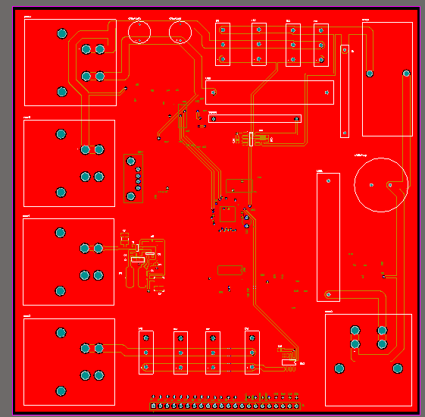

Fig. 8 Power layer of Intellaturbine PCB

IX. Conclusion

It was the intent of Intellaturbine to research and design an intelligent, alternative power source capable of sustaining the average household. Valuable experience was gained by each team member as several fields of engineering had to be explored to design the overall project. The project was composed of mainly the electrical and computer engineering disciplines, but there was also a mechanical aspect relating to the turbines, as well as procurement and budgeting for all the parts needed.

The team had steep learning curve during the research segment of this design as every group member was overwhelmed with new technology and trying to identify compatible components. However with the knowledge and systematic approach that was learned as engineering students, the team was able to understand the concepts presented to them and apply it to designing the project to the required specifications.

The design aspect of this project proved to be challenging. Unlike the classroom setting where students are usually taught principles or given a question with a definite answer, designing a project in the real world is somewhat different. First of all the answers (project specification) are usually given and students have to work backwards to come up with the design. This makes it difficult because it’s not just a case of solving a mathematical equation but finding parts and equipment meeting the design requirement that are also compatible with each other.

The last and probably most important segment of the senior design project is testing. The testing section not only demonstrates that the design works but also that it is within specification. Since this project is unique to each group member the team had to come up with its own series of repeatable test. Testing each segment separately before combining and testing the overall unit makes troubleshooting simpler. Multiple testing methods had to be developed because not only is testing held in the ever changing real world, tolerances in the parts and design had to be accounted for too.

Acknowledgement
The authors wish to acknowledge the assistance and support from our mentor and sponsor Shaun Dunbar.

Biography



Dwayne Smith is an Electrical Engineering student in his senior year at the University of Central Florida. His interest includes power systems and power electronics. Upon attaining his Bachelors of Science he hopes to work in the power generation industry preferably as a field engineer.

Joaquim Thompson is a senior in the electrical engineering college at UCF with and interest in control systems, signal processing, and power systems. Upon graduation he plans to work in one of his areas of interest and return to school to pursue a master’s degree.


Timothy is an Electrical Engineering major with an interest in computer engineering and digital systems. Upon graduating he plans to move near the Silicon Valley area in California to pursue career opportunities in these fields.


Jose Dominguez is an Electrical Engineering major with a minor in Intelligent Robotics. He planning to attend graduate school in the near future and specialize in Digital Signal Processing (DSP). His areas of interest include artificial intelligence, Computer Vision and Machine learning.

References
[1] D. Schelle and J. Castorena, “Calculating the inductor value is most critical in designing a stepdown” Buck-Converter Design Demystified, pp. 46-53, June 2006.
[2] “HowStuffWorks 'Modern Wind-Power Technology’” HowStuffWorks “Science” HowStuffWorks.com Web 13 Nov. 2007
[3] International Rectifier “Product Information Power Integrated Circuits
[4] T. Esram and P. L. Chapman, “Comparison of photovoltaic array maximum power point tracking techniques,” IEEE Transactions On Energy Conversion., vol. 22, pp. 439-447, June 2007

[5] “TLGwindpower” TLG-500 wind turbine.

[Online] Available: http://www.tlgwindpower.com/

